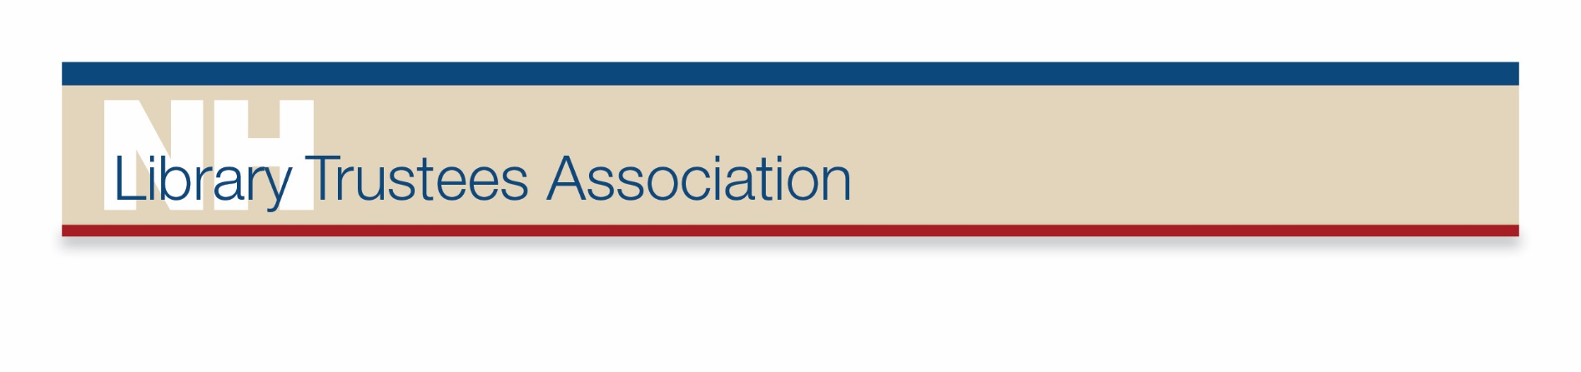

**Mildred McKay Conference or Workshop Scholarship Application**

To encourage trustee and library staff education, scholarships to NHLTA, NHMA, NHLA,  
NELA, and ALA conferences or workshops are offered to NHLTA members.

Name

Home Mailing Address: Street/PO Box

City/Town State Zip

Preferred phone: Email:

Library Name: Library City/Town:

Check one: ⬜ Trustee ⬜ Alternate ⬜ Library Staff, position:

EVENT Check one: ⬜ NHLTA Conference ⬜ Other Conference ⬜ Workshop

Title of Conference or Workshop:

Sponsored by: Location:

Date(s) Cost:

Conference or Workshop Description:

Reason for selecting the Conference or Workshop~~:~~

Other Information:

Signature: Date:

Please complete the application and email to: [j.palleiko@nhlta.org](mailto:j.palleiko@nhlta.org)

Or mail the application to: Jeanne Palleiko, PO Box 526, Newbury, NH 03255.

*(FOR NHLTA USE ONLY)*

Date Received

Approvals

Check # Check Date NHLTA Treasurer

REVISED 2-2025